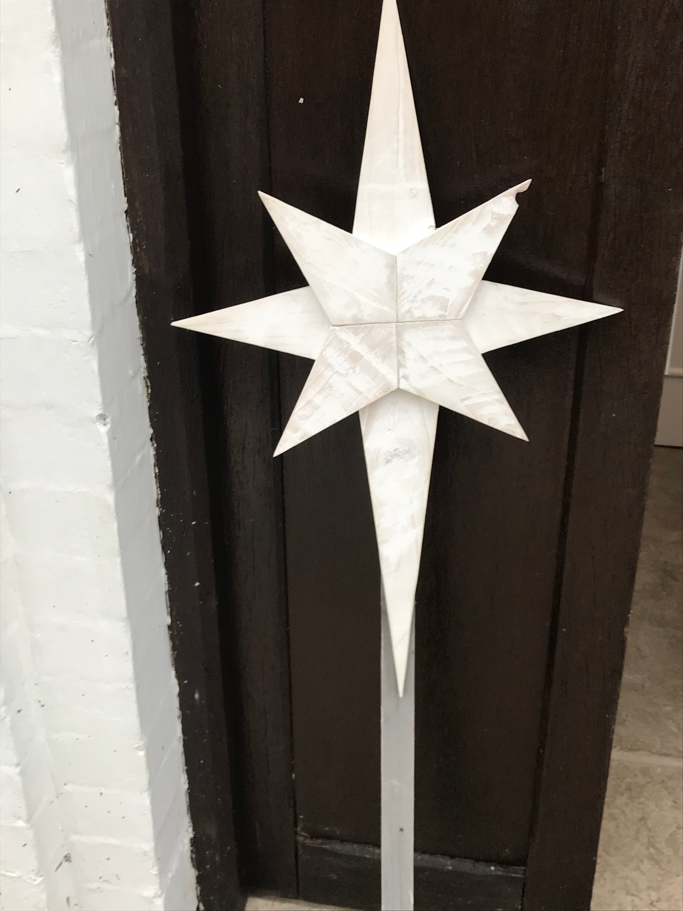

Advent in the Garden
The journey round the garden follows the Carmelite pattern for advent of Waiting, Accepting, Journeying and Birthing. In the last week we will add Seeing round the back, reminding us of God with us.
You are invited to travel at your pace around the garden, if you want to take photos to remind you for later reflection feel free. Use the resources that are available, please leave the main elements in place.

Waiting

The coming
And God held in his hand
A small globe. Look. He said,
The son looked. Far off,
As though water, he saw
A scorched land of fierce
Colour. The light burned
There; crusted buildings
Cast their shadows, a bright
Serpent, a river
Uncoiled itself, radiant
With slime,
On a bare
Hill a bare time saddened
The sky. Many people
Held out their thin arms
To it, as though waiting
For a vanished April
To return to its crossed
Boughs. The son watched
Then. Let me go there, he said. RS Thomas

Mary is the first human to hear the reality of the son’s offer, she hears it from an angel, who God sends. (Luke 1:26-38 Here begins another waiting period, waiting for her parents response, her partner’s response, waiting…..

2020 has been a year of waiting… waiting to see whether the virus will come to us, waiting to see family and friends, waiting for a vaccine, waiting

Advent is a time of waiting, it happens every year, we wait for Christmas, for the coming of God with us…

What are you waiting for?
Take a paper angel and offer your prayers for what you are waiting ?
Pray for God’s presence in your waiting

Accepting

The Bright Field

I have seen the sun break through
To illuminate a small field
For a while, and gone my way
And forgotten it. But that was the pearl
Of great price, the one field that had
The treasure in it. I realise now
That I must give all that I have
To possess it. Life is not hurrying.

On to a receding future, nor hankering after
An imagined past. It is the turning
Aside like Moses to the miracle
Of the lit bush, to a brightness
That seemed as transitory as your youth
Once, but is the eternity that awaits you. RS Thomas

A moment of acceptance of God’s grace, reflecting the reading which says @ the kingdom of God is like this” (look up reference). Time to accept and move into the transforming light of God.

Under the tree you will find a treasure box of ribbons, choose one and tie it to the tree, the colours transform the tree the tree like that burning bush.
AS you tie it, take a moment to consider what you need to accept and what needs to be transformed by the grace of God.

Take time to turn aside and rest in God’s presence. Accept what God is offering you

Journeying

Evening

The archer with time
As his arrow- has he broken
His strings that the rainbow
Is so quiet over our village

Let us stand, then, in the interval
Of our wounding, till the silence
Turn golden and love is
A moment eternally overflowing. RS Thomas

Those magi followed a star, the star we have is a Bethlehem star, like one they would have followed. They journeyed towards Bethlehem on guided on their way, do you ever wonder about the days when the sky was cloudy and covered up the star, the moments of stillness and stopping, the moments of reflection that this poem speaks of.

Do you ever wonder about those they met on the journey and how they affected them?
About the footprint of their journey towards Bethlem…

As you reflect on the journey you are making here and beyond the garden look at your shoes, what footprint do they leave- maybe put a print in the soil…. Pray that you will make a positive impression on your journey…

Maybe you need to pray for a moment of stillness to reflect on the way you have come and the way you are going.

Birthing

The un-born
I have seen the child in the womb,
Neither asking to be born
Or not to be born, biding its time
Without the knowledge of time
Model for the sculptor who would depict
The tranquillity that adheres
Before thought, or the purity of thought
Without language. It’s smile forgave
The anachronism of the nomenclature
That would keep it foetal. Its hands
Opened delicately as flowers

In innocency’s garden, ignorant
Of the hands growing to gather them
For innocency’s grave.
Was its part written? I have seen
It waiting breathlessly in the wings
To come forth on to a stage
Of soil or concrete, where wings
Are a memory only or an aspiration. RS Thomas

Birthing gives us a sense of newness of possibility, the angel offers this to Mary & to the world. The star guides our journey into newness. The world is made new by the coming of Jesus at Christmas and possibilities unfold, like those fingers in the womb

Maybe it reminds you of Psalm 139 inviting us into the fragility and the strength of new life, life traveling in the darkness of the womb to the raw brightness of early life.

Take time to reflect on the hopes you are travelling to….

What is the raw brightness of the future…….

Look at your hands, clench them to remind yourself of the hard things and the tension…….

Allow them to relax and unfold, to remind you that there is hope and possibility

Seeing (this will be added in the week beginning 20/12)

The Kingdom

It’s a long way off but inside it
There are quite different things going on
Festivals at which the poor man
Is king and the consumptive is
Healed; mirrors in which the blind look
At themselves and love looks at them
Back; and industry is for mending
The bent bones and the minds fractured
By life. Its’s a long way off, but to get
There takes no time and admission
Is free, If you will purge yourself
Of desire, and present yourself with
your need only and the simple offering
of your faith, green as a leaf. RS Thomas

the crib is round the back! Hidden from view God comes, to travelling parents far from home, for outcast shepherds and to foreigners on a journey.

Sit by the crib, look on the baby, let God look on you

Maybe imagine yourself 2000 years back, who are you, travelling, outcast, foreign, remember God came to you and comes now.

God is with me
God is with you
God is with us

